1. select * from SDE.show_active;

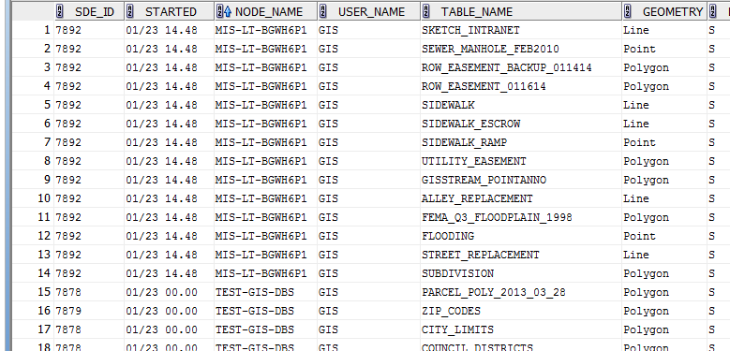

1. SELECT pi.sde_id, server_id, start_time, nodename,owner,direct_connect FROM sde.process_information pi;

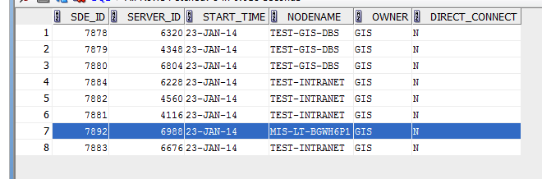

1. SELECT s.sid, s.serial# FROM v$session s

WHERE SUBSTR(s.process,1,INSTR(s.process,':')-1) =

(SELECT pi.server_id FROM sde.process_information pi WHERE pi.sde_id = 7892);

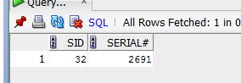

1. ALTER SYSTEM KILL SESSION '32,2691' IMMEDIATE;

